**Connect 4 -Game**

**REPORT**

# **Requirements:**

Connect Four is a two-player game with perfect information for both sides, meaning that nothing is hidden from anyone. Connect Four also belongs to the classification of an adversarial, zero-sum game, since a player's advantage is an opponent's disadvantage.

One measure of complexity of the Connect Four game is the number of possible games board positions. For classic Connect Four played on a 7-column-wide, 6-row-high grid, there are 4,531,985,219,092 positions[5] for all game boards populated with 0 to 42 pieces.

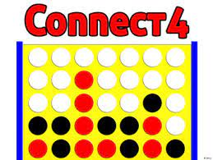The game was first solved by James Dow Allen (October 1, 1988), and independently by Victor Allis (October 16, 1988).[6] Allis describes a knowledge-based approach,[7] with nine strategies, as a solution for Connect Four. Allen also describes winning strategies[8][9] in his analysis of the game. At the time of the initial solutions for Connect Four, brute-force analysis was not deemed feasible given the game's complexity and the computer technology available at the time.

**Objectives:**

* To be the first player to connect 4 of the same colored discs in a row (either vertically, horizontally, or diagonally)

**HOW TO PLAY:**

* First, decide who goes first and what color each player will have.
* Players must alternate turns, and only one disc can be dropped in each turn.
* On your turn, drop one of your colored discs from top into any of the seven slots.
* The game ends when there is a 4-in-a-row or a stalemate.
* The starter of the previous game goes second on the next game.

**Strength:**

## ****1. Provides fun and entertainment.****

Connect 4 is not a boring game by any means. Kids introduced to it often become quite fixated with it. When they are up against you or another family member, they are bound to have heaps of fun, focusing on beating you. If you need to while away a few hours or get through a rainy day, Connect 4 is a great entertainment option for the family.

## ****2. Develops fine motor skills.****

Kids take time to develop [fine motor skills](https://www.verywellfamily.com/what-are-fine-motor-skills-2162037). This is the ability to coordinate small muscles and movements. This can mean using the hands and fingers correctly to correlate to what they see with the eyes. It is about matching up the movement of hands and fingers (as an example) with what they see in front of them.

## ****3. Improves basic counting and mathematics skills.****

In order to play Connect 4, children need to learn basic counting and simple maths. They will need to be able to do basic addition at the very least. If you start playing Connect 4 with a child that cannot even count to 4 as yet, you will find that they very quickly learn to do so.

## ****4. Boosts strategic thinking capabilities.****

Winning a game of Connect 4 is about strategy. You have to outwit and outsmart your opponent, which means that you have to be thinking strategically with each and every move. Because of this, Connect 4 is a great way to kick-start a child’s strategic thinking capabilities.

**Weakness:**

* Can only play with an internet connection
* Lack of physical activity

**Flowchart:**

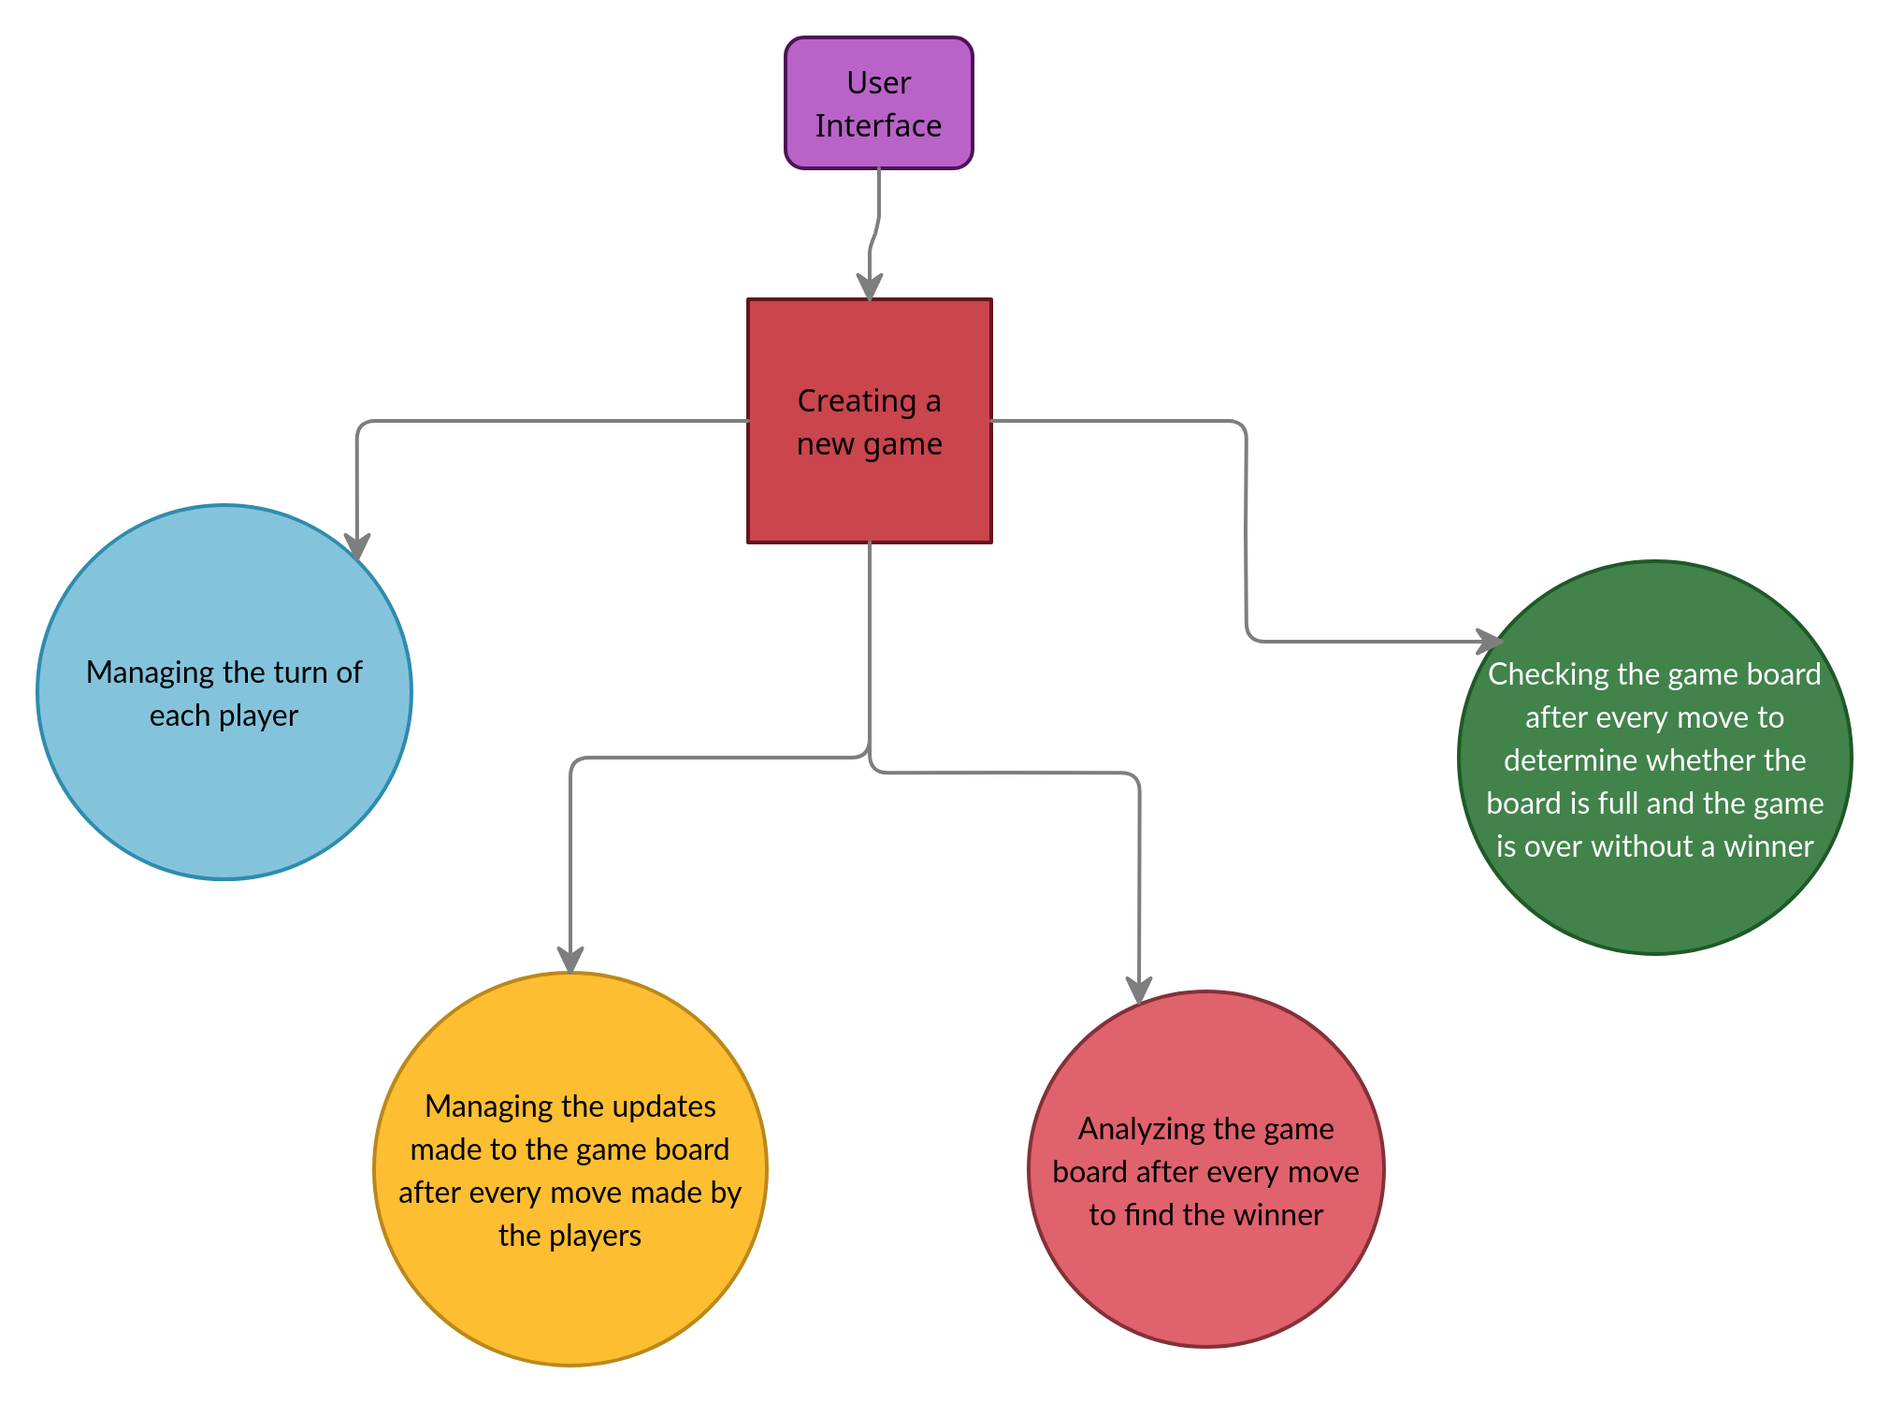

**Conclusion:**

The solved conclusion for Connect Four is first-player-win. With perfect play, the first player can force a win, on or before the 41st move by starting in the middle column. The game is a theoretical draw when the first player starts in the columns adjacent to the center.